"Behold the Lamb of God
who takes away the sins of the world"
These are the profound words of the Mass that our priests proclaim when they elevate our Lord after the consecration. We believe that the bread and wine have changed into the Body and Blood of our Lord, Jesus Christ, and we bring that belief with us to the holy hour we spend with our Lord in Eucharistic Adoration.
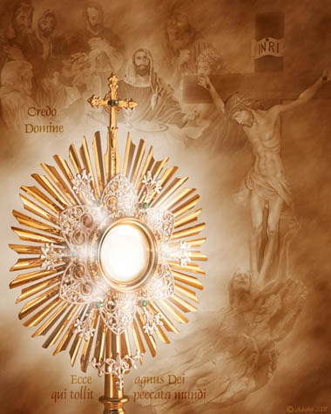
The proclamations "Ecce agnus Dei qui tollit peccata mundi" (Behold the Lamb of God who takes away the sins of the world), and, "Credo Domine" (Lord I believe), are words of faith from the disciples that we continue to profess to this day because we know that our Lord is truly present in the Eucharist.

"I WILL NOT LEAVE YOU ORPHANS"
O my child, son of the Cross and of my Heart: your father and mother may fail you, but I will never abandon you!
Even at my death I did not leave my children orphans, for day and night they can find me on their altars.
With the tenderness and gentleness of a thousand mothers, the Last Supper came to sweeten the bitterness of Calvary; for I knew that in the Holy Eucharist you would always have with you a father and a mother, and would never be alone while on earth...
And, therefore, although my Passion caused me excessive sufferings, yet I found consolation and relief in the thought that I was to leave myself to you in the Holy Eucharist.
I wished, my beloved child, that my body, which was crushed under the burden of the cross, and my blood, which was shed for all mankind, should be, within the Sacrament, your consolation and joy.
I wished it... my dearly beloved child. In those supreme moments of indescribable anguish, the thought that you would be happy in the possession of the Holy Eucharist increased my strength during My passion, and lessened My fear. And that is why the Institution of this Holy Sacrament immediately preceded My greatest sufferings.
It could not be otherwise, my dearly beloved child, than that the thought of always living by your side would lessen and alleviate My sufferings.
It was this thought that caused me to sing the song of thanksgiving with joy as I walked with my Apostles to the Garden of Olives. And during the painful moments of my Passion, I had continually before my mind those sweet hopes which had been with me during the Last Supper.
When my body was being scourged cruelly... and when my blood was pouring on the ground, I rejoiced, my dearly beloved son. I rejoiced at being ground like wheat in the mill and pressed like grapes in the winepress, thus making myself the bread and the wine to nourish you at the Eucharistic banquet.
Before death had taken me away from men, I had disposed and arranged to multiply my life upon their altars.
Do you not see then my child, that even in dying I have not left you as an orphan; for every day and at every moment of the day, from one end of the world to the other, these words of my Priests rise to Heaven: "This is My Body. This is My Blood"; and I rejoice at being a constant victim for love of you.
O Jesus, O my beloved Jesus! O Jesus hidden here beneath these Sacramental veils! Grant that at every moment of my life I may return gratitude and love to you for your great love for me!
O Mary, my Mother, our Lady of the Eucharist! Help me to offer thanks to Jesus, and always to prepare myself perfectly to receive Him with a love like yours. Amen.
From the book "Before the Altar", by Concepcion Cabrera de Armida
Permission received by Fr. Gustavo Garcia-Siller M.Sp.S (Missionaires of the Holy Spirit)

